# SQL Moderation Hack – Case Study and Parameters

## PROBLEM STATEMENT

You have 3 SQL Server 2008r2 Database(s) on a single Azure VM, used by an Application “Online Transaction Monitor”. The Databases and Application need to be migrated from SQL Server 2008r2 to latest versions of SQL Server. The business would like to minimize patching and maintenance for the future but maintain full functionality. However, the Application source code is lost, the only configuration change you can make is the Connection String.

Task: Migrate Databases form SQL Server 2008r2 to suitable environment, with successful test of application, meeting all business objectives.

## LAB INSTARUCTIONS

Time: 1 Hour

**For Connection Strings and Passwords see LAB ENVIROMENT and APPENDIX**

1. Test the Online Transaction Monitor with the databases held on SQL Server 2008R2 Legacy server (IP: 10.0.2.4) using your TEAM assigned databases and Login
2. Plan your 3 databases for migration, using the Database Migration Assistant. Are the Legacy Databases best suited for Azure SQL Database Single or Azure SQL Managed Instance?
3. Use the Database Migration Service to Migrate your 3 Databases and Login from the Legacy SQL Server 2008R2 to the Azure SQL Database
   1. See Appendix for connection strings
   2. SAS URI Key is available in C:\_SQLHACK_\LABS\01-Data_Migration\SASKey.txt
4. Test your Migration by using the Setting screen to update the connection string (Instructions below)
5. Note any errors and work through SQL fixes held within C:\_SQLHACK_\LABS\01-Data_Migration\Migration Helper Script.sql

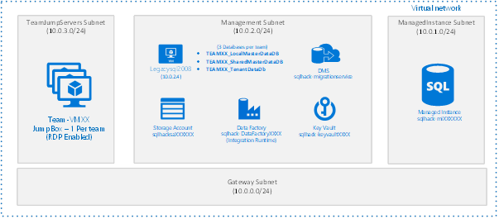

**NOTE: There are 20 workshop environments using a SHARED source SQL Server and Target Azure SQL Database. Please be respectful of only migrating your teams Databases and Logins.**

**FULL SOLUTION GUIDE IS AVAILIBLE IN C:\_SQLHACK_\LABS\01-Data_Migration\– DB Migration Guide – FULL.pdf**

## LAB ENVIROMENT

From the demonstrations we have setup a lab environment for you to become familiar with an offline (restore from backup) migration. Offline (restore from backup) is the most common migration approach supported by Azure Database Migration Service (DMS).

Each workshop has a set of parameters that are used specific to their workshop (e.g. usernameX, password, server). Use the parameters shown below to use your assigned workshop.

## APPLICATION – Online Transaction Monitor

The online Transaction Monitor is a simple application that lists the number of transactions for a given country. The data for this application is held in 3 databases on a SQL Server 2008 r2 Server.

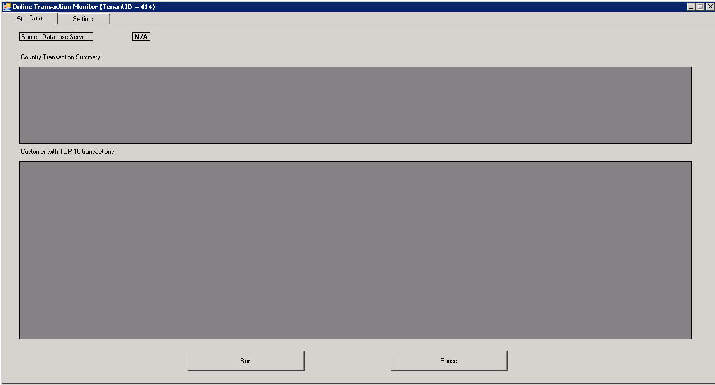

These databases are named (replace XX with your team name):

* TEAMXX_LocalMasterDataDB
* TEAMXX_SharedMasterDataDB
* TEAMXX_TenantDataDb

The SQL Databases use CLR with an assembly embedded in the TEAMXX_TenantDataDb.

Additionally, the Application currently uses a SQL LOGIN which must also be considered. The Login is DB_Owner of each of the 3 TEAM databases only. The SQL Login for your team is:

* Login Name: TEAMXX
* Password: TEAMXX

## Changing the connection string

The Application can be configured through its setting screen:

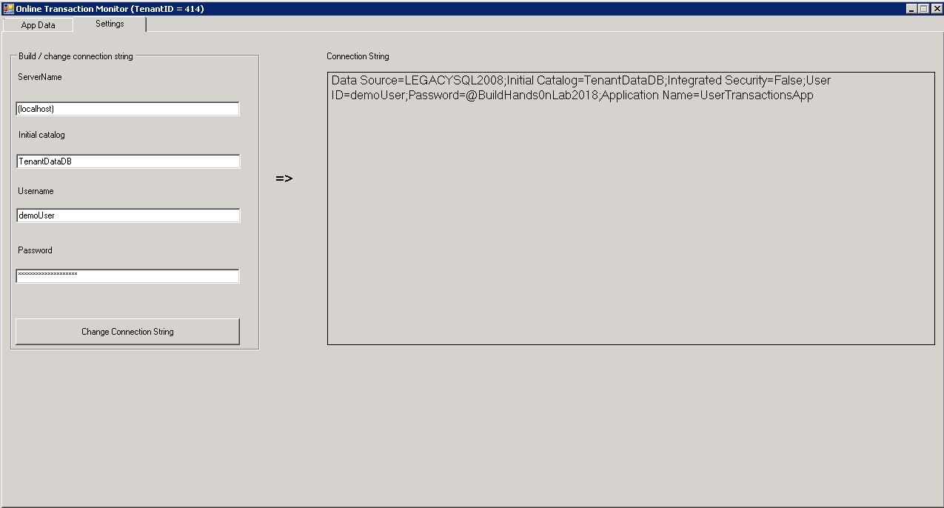

The Settings that can be changed include:

* ServerName: IP Address of the SQL Server
* Initial Catalog: TEAMXX_TenantDataDb
* UserName: TEAMXX
* Password: TEAMXX

## APPENDIX

## Source SQL Server

|  |  |
| --- | --- |
| **IP Address**  (use this for connections) | **10.0.2.4** |
| **Server Name** | **LEGACYSQL2008** |
| **Resource Group** | **SHARED** |
| **SQL Login Name:**  (Use for Application Connection)  (Replace XX with Team number) | **TEAMXX** |
| **SQL Login Password:**  (Use for Application Connection)  (Replace XX with Team number) | **TEAMXX** |
| **Databases:**  (Replace XX with Team number) | * **TEAMXX_LocalMasterDataDB** * **TEAMXX_SharedMasterDataDB** * **TEAMXX_TenantDataDb** |

## Target SQL Server

|  |  |
| --- | --- |
| **IP Address**  **(use this for connections)** | **Sqlhack-mi.XXXXXXXX.database.windows.net** |
| **Server Name** | **Sqlhack-mi** |
| **Resource Group** | **SQLHACK-SHARED** |
| **Admin Login Name:**  **(Use for Migrations)** | **MIGRATION** |
| **Admin Login Password:** | **Demo@pass1234567** |

## Database Migration Service

|  |  |
| --- | --- |
| **Service Name** | **sqlhack-migrationservice** |
| **Resource Group** | **SHARED** |
| **Migration Project Name**  (Replace XX with Team number) | **TEAM XX** |
| **Target Server Type** | **Azure SQL Managed Instance** |
| **Migration Source SQL Instance Name** | **10.0.2.4** |
| **User Name** | **demouser** |
| **Password** | **Demo@pass1234567** |
| **Encrypt Connections** | **No** |
| **Target Server Name** | **Sqlhack-mi.XXXXXXX.database.windows.net** |
| **User Name** | **demouser** |
| **Password** | **Demo@pass1234567** |
| **Source Databases (3 Database only)**  **(Chose only those related to your Team number)** | * **TEAMXX_LocalMasterDataDB** * **TEAMXX_SharedMasterDataDB** * **TEAMXX_TenantDataDb** |
| **Select Logins (1 Login Only)**  **(Chose only those related to your Team number)** | **TEAMXX** |
| **Chose Backup Option** | **I will Let Azure Database Migration Service create Backup files** |
| **Backup Settings – Network Share Location** | **\\10.0.2.4\FILESHARE** |
| **Backup Settings – Windows User to impersonate** | **legacysql2008\demouser** |
| **Backup Settings – Windows Password** | **Demo@pass1234567** |
| **Storage Account Settings – SAS URI** | **See File**  **C:\_SQLHACK_\LABS\01-Data_Migration\SASKey.txt** |